Project Development Approach
TCS follows a well-defined process during different phases of the project. The essence of the process is a structured method of process control using checklists of activities with specific Entry criteria, Tasks, Validation procedures, and exit criteria (ETVX), in conjunction with a focus on process management including defect prevention.

ETVX stands for:
ENTITY | DESCRIPTION
Entry Criteria | A checklist of conditions that must be satisfied before beginning the activity.
Tasks | A set of tasks that need to be carried out during the phase
Validation & Verification | A list of validation tasks to verify the quality of the work items produced by the activity.
Exit criteria | A checklist of conditions that must be satisfied before the activity is completed.
Table .ETVX Process

Planning and Start-up
The initial planning activities and understanding the scope of the business requirements, tec eco system selected, key stakeholders identified, funding approval, team and time lines are identified in this phase.

Planning and Start-up ETVX Model
Entry Criteria | - Signed contract or formal agreement for start of project
Task | - Meeting / Workshops with bose  - Define scope of the project  - Prepare Project Plan  - Understand tech eco system  - Identify the key stakeholders  - Collect/Define Project Standards  - Project Standards Documents  - Define meeting requirements  - Establish QA/QC procedures and finalize & share audit requirements  - Identify risks and mitigation plan  - Identify the team  - Estimate funding for each phase
Verification and Validation | - Review Project Plan  - Review funding for each phase  - Review team details and time lines  - Review of Project Standards Document  - Review QA/QC procedure and audit requirements
Exit criteria | - Project Plan is released  - Tech echo system identified  - Key stakeholders identified.  - Baselined Project Standards Document  - Funding approval for each phase.  - TCS Resources are identified and allocated to project
Table Planning and Start-up ETVX Model

Analyze

The business rules , detailed process flow , user experience, high level design, infrastructure design are discussed and finalized in this phase.

Requirements Analysis – Process Flow

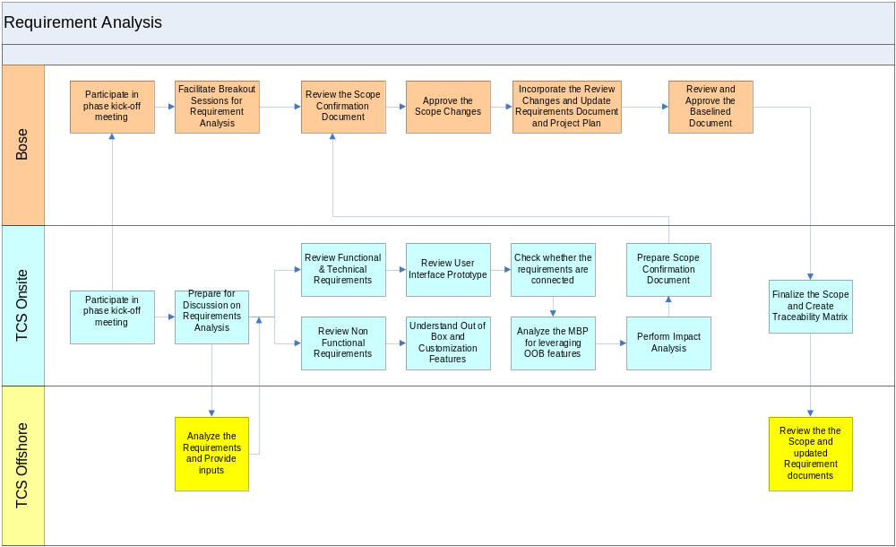
Figure - Requirement Analysis Process Flow

Requirement Analysis ETVX Model

Entry Criteria | - SME/Analyst availability  - Project plan and Standards  - Unified Project Plan is signed off and baselines  - Bose to provide their requirement documents  - KT transition document is available
Task | - Participate in phase kick-off meeting  - Review and understand the requirements  - Prepare global requirements document  - Identify localization requirements  - High-level solution architecture  - Review Functional & Technical Requirements  - Review Security requirements  - Review Non-functional Specification  - Review User Interface and all creative artefacts  - Perform Impact Analysis  - Scope Confirmation document  - Check whether the requirements are connected  - Create Traceability Matrix  - Understand Out of Box and Customization Features  - Understand Reusable list from MBP  - Baseline the requirements and sign-off
Verification and Validation | - Review base lined requirements and scope  - Review High-level solution architecture  - Review Traceability Matrix  - Review of updated Project Plan  - Review of functional and non functional scope
Exit criteria | - Requirements are base lined and signed off by Bose  - Updated project plan is released  - Solution architecture document is created  - Traceability document is updated
Table 1.Requirement Analysis ETVX Model

Technical Design

This phase covers the activities towards the architecture and design of this system.

Technical Design – Process Flow

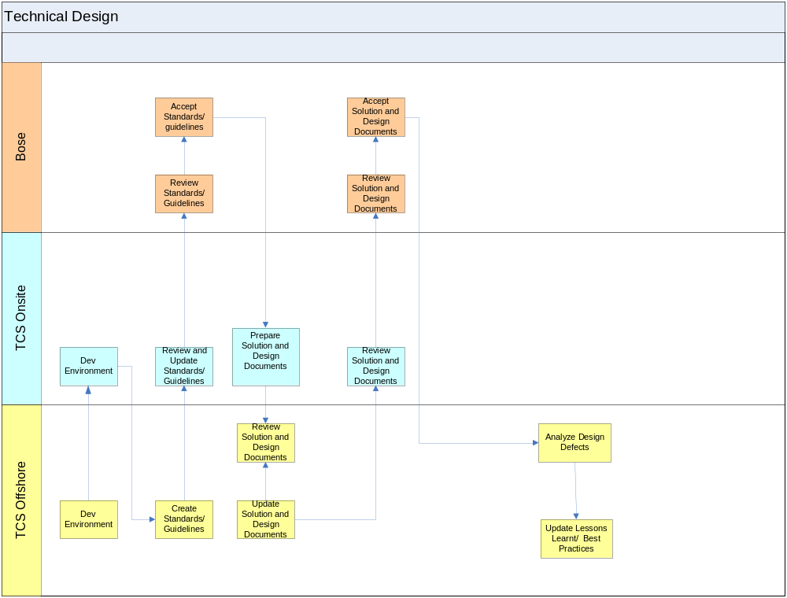
Figure - Technical Design Process Flow

Technical Design ETVX Model

Entry Criteria | - Project Plan and Standards are available  - Requirements document
Task | - Onsite and Offshore workspace setup  - Create /adopt Standards/ Guidelines  - Group the requirements  - Decide on the design dependency  - Create High Level Design  - Create Low Level Design  - Create Database design  - Create Interface and Batch Design specifications
Verification and Validation | - Review Design Document  - Review Standards and Guidelines
Exit criteria | - Signed-off Design Document  - Signed of High Level Design document  - Setup of development environment
Table 2.Technical Design ETVX Model

Construction & Unit Testing

This phase covers the activities directed towards the construction of the production status site development.

Construction and Unit Testing – Process Flow Diagram

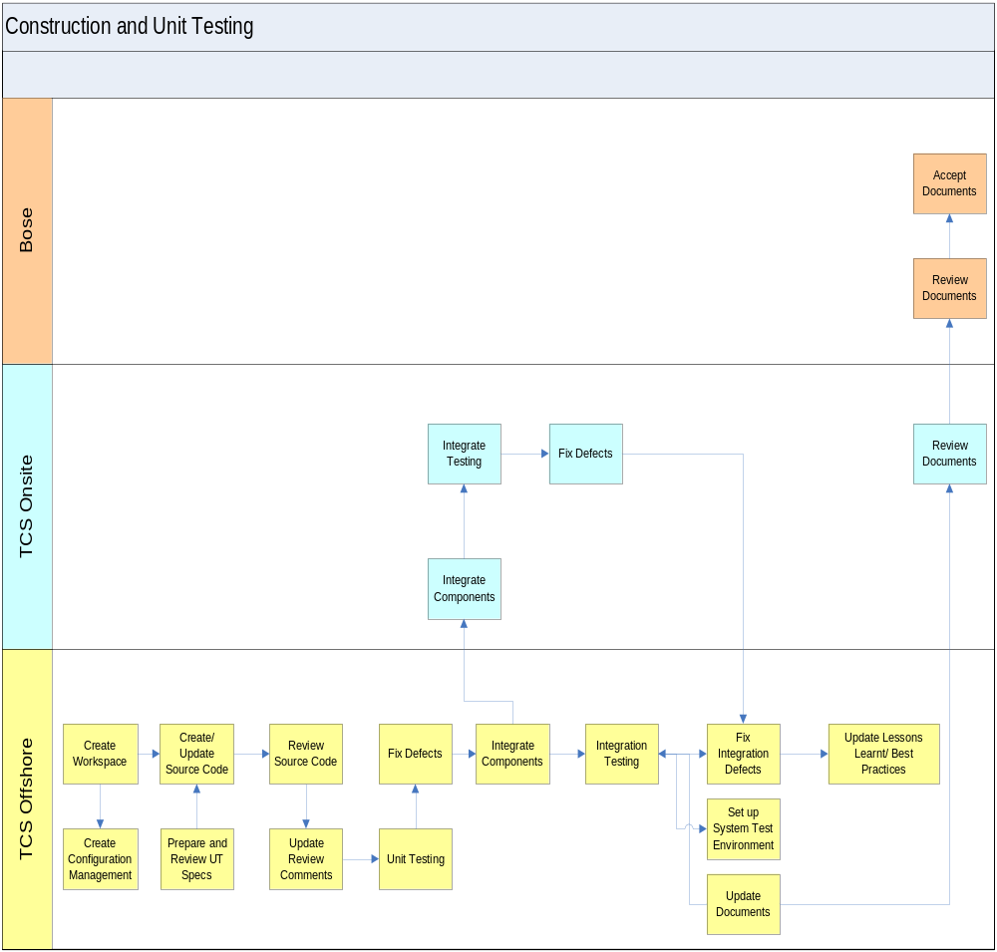
Figure 19 - Construction & Unit testing Process Flow

Construction and Unit Testing ETVX Model

Entry Criteria | - Project Plan is available  - All Design Artifacts are available and signed off
Task | - Set-up development workspace for construction  - Configuration Management  - Develop the System  - Prepare Unit Test Plan  - Prepare Test Data  - Conduct Unit Test  - Prepare System and Integration Test Plan  - Perform Integration Testing
Verification and Validation | - Review Code  - Review Unit Test Results  - Review System and Integration Test Plan
Exit criteria | - Unit and Integration tested application is available  - Reviewed System and Integration Test Plan is available.
Work Items | - Unit Tested Code  - System and Integration Test Plan
Table 3.Construction & Unit Testing ETVX Model

System Testing

This phase is carried out to perform the System Testing of the application.

Integration & System Testing – Process Flow Diagram
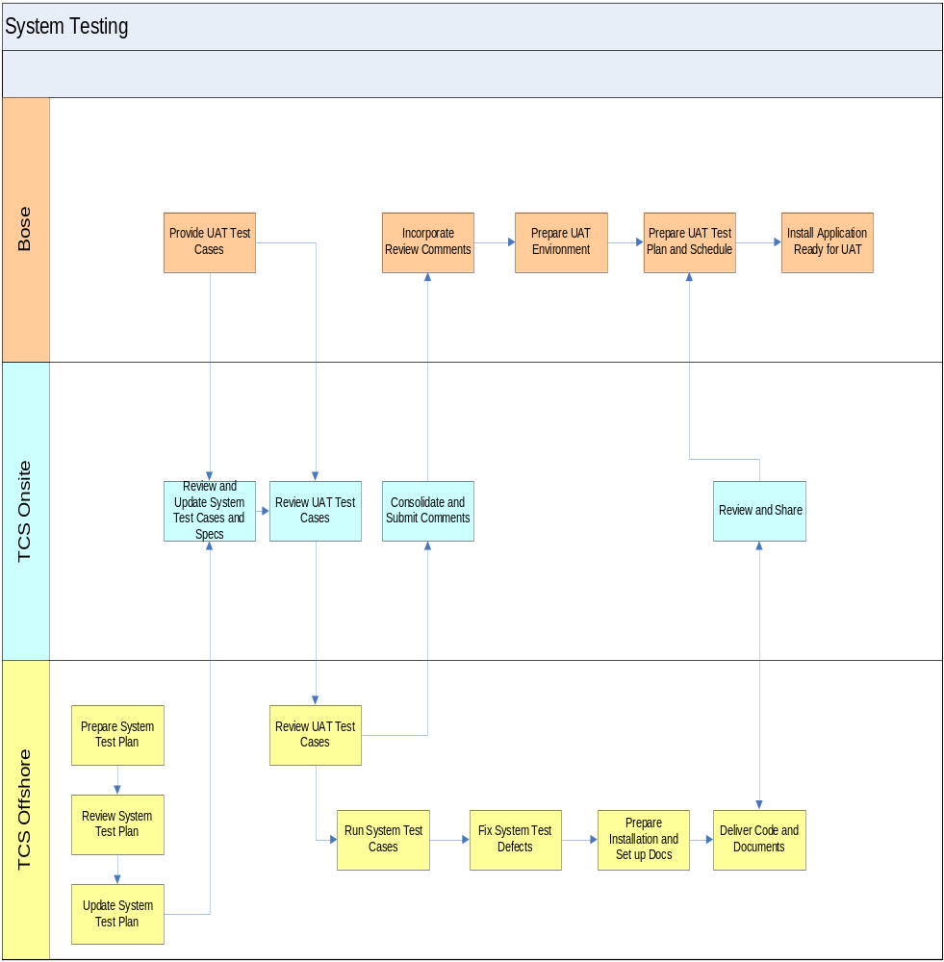
Figure 20 - System testing Process Flow

Integration & System Testing ETVX Model

Entry Criteria | - Project Plan is available  - Successfully unit tested code is available  - HLD and Detailed Design Document are available  - System Test Plan is available  - System test cases and test data are available
Task | - Perform System Testing  - Prepare environment for acceptance testing  - Release tested system Release system test results  - Release completed user documents  - Assist in environment preparation for user acceptance test
Verification and Validation | - Review Test Results.  - Review completed user documents  - Review Traceability Matrix  - Review system test results
Exit criteria | - System tested application is available  - System tested code is delivered to Bose  - Completed user documents are delivered to Bose  - Environment for acceptance test is available  - Updated project plan is released
Table 4.Integration & System testing ETVX Model

User Acceptance Testing

UAT-Process Flow Diagram
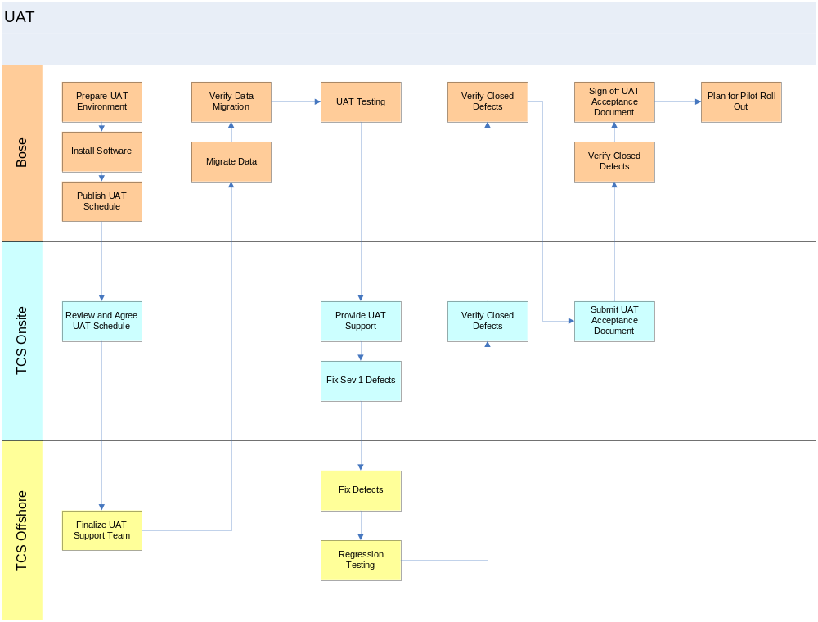
Figure 21 - UAT Process Flow

User Acceptance Support-ETVX Model

Entry Criteria | - UAT Plan is available  - UAT Test Cases are available  - System Tested code is available  - Stake holders are identified and informed  - Test Data is available
Task | - Perform UAT  - Release Test results  - Fix the issues arises out of TCS Scope of Work  - Prepare environment for Soft Launch  - Assist in environment preparation for Soft Launch
Verification and Validation | - Review Test Results.  - Review completed user documents  - Review Traceability Matrix  - Identify the open and known issues
Exit criteria | - Provide Acceptance  - Accepted System is available  - Environment for soft launch is available  - Updated project plan is released
Table 5-UAT ETVX Model

